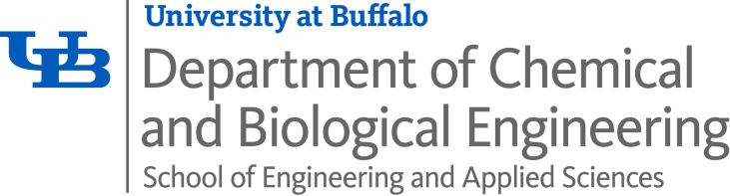

Chemical Engineering Graduate Degree Requirements-Fall 2023

Ph.D. – Minimum of 72 credit hours total, including:

- Successful completion of Ph.D. qualifying exams, dissertation document, and dissertation defense
- Maximum 30 credits of dissertation, CE 659 (fall) & CE 660 (spring)
- Minimum of 24 credits of formal CE lecture courses, including:
  - Four of the following 6 core courses (3 credits each; offered in the fall), with a minimum of 2 courses selected from the sub-set of: CE 509, CE 525 and CE 561:
    - CE 509 – Transport Phenomena
    - CE 525 – Adv. Chemical Thermodynamics
    - CE 561 – Applied Chemical Kinetics
    - CE 540 – Materials Principles
    - CE 517 – Bioengineering Principles
    - CE 531 – CE Mathematics & Computation
  - Research Methods 1, CE 630 (spring), and Research Methods 2, CE 631 (fall), 6 credits total
  - One semester of Supervised Teaching, CE 599, 3 credits
  - One graduate course, 3 credits, or an additional semester of CE 599, 3 credits
    - Note: Two semesters of supervised teaching are required for the program but only one is required for registration
- Maximum of 18 credits of informal courses, e.g. Individual Problems, CE 601 (fall) & CE 602 (spring)
M.S. – Minimum of 30 credit hours total, including:
- Track 1 and 2
- Minimum of 18 credits of formal CE lecture courses, including:
  - One of the following core courses (3 credits each; offered in fall): CE 509, CE 525, or CE 561
- Minimum of 6 credits of informal courses: Individual Problems, CE 501 (fall) & CE 502 (spring)
- Maximum of 5 credits of Master’s Research, CE 506 (summer, fall, & spring)
- Culminating Experience:
    - Track 1: Thesis Option
      - 1 credit of Thesis, CE 559 (fall) or CE 560 (spring)
      - Successful completion of thesis document and thesis defense
    - Track 2: Non-Thesis Option
      - 1 credit of Engineering Projects, CE 503 (fall) or CE 504 (spring)
      - Successful project completion and project defense
- Track 3
- Minimum of 24 credits of formal CE lecture courses
- Maximum of 6 credits of informal courses: Individual Problems, CE 501 (fall) & CE 502 (spring) or Internship, CE 596 (summer, fall, & spring)
- Culminating Experience:
  - Successful completion of ePortfolio

M.Eng. – Minimum of 30 credit hours total, including:
- Minimum of 18 credits of formal CE lecture courses
- Maximum of 6 credits of informal courses: Individual Problems, CE 501 (fall) & CE 502 (spring) or Internship, CE 596 (summer, fall, & spring)
- Maximum of 5 credits of Master’s Research, CE 506 (summer, fall, & spring)
- Culminating Experience:
  - At least 1 credit of Engineering Projects, CE 503 (fall) or CE 504 (spring) and successful project completion, approved by faculty advisor or
  - At least 1 credit of Internship/Practicum, CE 596 (summer, fall, & spring) and successful completion of an internship/practicum
Notes:
- A maximum of two graduate courses may be taken outside of the CBE Department, per advisor approval, and be applied toward an above graduate degree as long as doing so does not interfere with other requirements.
- Graduate courses completed prior to joining the Chemical and Biological Engineering Department at the University at Buffalo from accredited or recognized institutions of higher education and with grades of 'B' or better are eligible for consideration for transfer credit. Up to 6 credits may be transferred toward a Master’s degree and up to 36 credits toward a PhD degree at UB. Please contact the CBE Graduate Academic Coordinator for further information.

