Career and Degree Exploration Mini-Project
Contents
Overview 2
Part 1: Current Academic Progress 3
Grade Benchmarks for Required Classes 3
Academic Behaviors 4
Part 2: Focus2 Self-Assessment with Reflection 6
Making an Account 6
Work Interest Assessment 6
Personality Assessment 8
Leisure Assessment 8
Combine Assessments 10
Part 3: Informational Interviews 11
Discussion #1: Someone You Admire 11
Discussion #2: A Junior or Senior in the Major 12
Discussion #3: Professional in the Field 13
Part 4 - Final Reflection 14

Overview
Choosing a career or a field of interest is not an easy task to accomplish. According to the National Center for Educational Statistics, 50% - 70% of all college students change their major at least once. Most will change their majors at least three times during their undergraduate career until they find the field that interests them and suits their strengths.
Many students choose an intended major with limited knowledge of potential careers. A purpose of this mini-project is to provide some direction for meaningful degree/career exploration. While you are doing this mini-project with the goal of being reconsidered for engineering or computer science, it is okay if this mini-project leads you to interests outside of those academic majors. We encourage you to explore with an open-mind, whether it leads you back to engineering or computer science, or elsewhere.
We developed this mini-project to provide you with a holistic view of your talents, interests, and academic strengths. It is in your best interest to take the time and fully explore every possible outcome. We recommend you follow this document in order as each part builds off of the previous one(s).
Lastly, if at any point you realize engineering or computer science is not for you, we encourage you to finish this mini-project and still meet with Career Services. Exploration is good and Career Services can support you as you find your new academic and career path.

Part 1: Current Academic Progress
Being successful in a particular degree program is a partnership between grades and academic behaviors. We want to make sure you are at the level needed to succeed. This includes comparing your grades to those who have successfully completed the engineering or computer science degrees and examining how your academic behaviors have changed over the last year.

Grade Benchmarks for Required Classes
Students looking to be reconsidered for an Engineering program should complete Table 1. Students looking to be reconsidered for a Computer Science program should complete Table 3. Please note the minimum course grade for the benchmark courses is a C-.

Engineering Core Courses Breakdown
Table 2 is for you to see how your core grades compare to the graduates from engineering. For example, if you received an A in MTH141, you are in the 1st Quartile with 30.2% of engeering graduates.

Table 1: Your Engineering Core Courses
Benchmarks | Your Grade | Your Quartile (see graph) | % of graduates who received your grade (see graph)
MTH 141/MTH 153
MTH 142/MTH 154
CHE 107
PHY 107

Table 2: Engineering Core Course Results from Graduating Students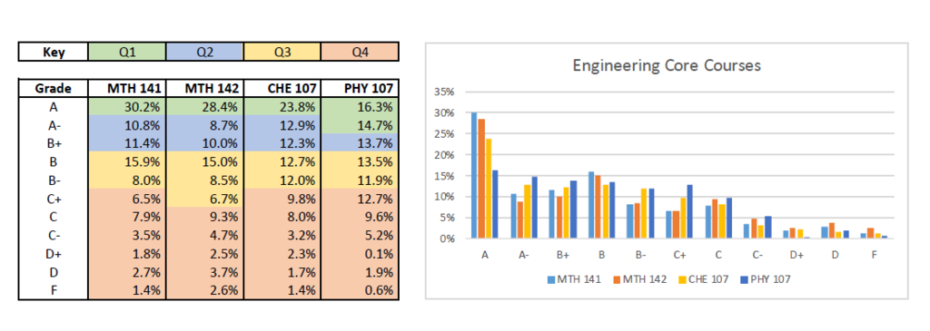

Computer Science Core Courses Breakdown
Table 4 is for you to see how your core grades compare to the graduates from engineering. For example, if you received an A in MTH141, you are in the 1st Quartile with 30.2% of engeering graduates.

Table 3: Your Engineering Core Courses
Benchmarks | Your Grade | Your Quartile (see graph) | % of graduates who received your grade (see graph)
MTH 141/MTH 153
CSE115
CSE116
CSE191

Table 4: Computer Science Core Course Results from Graduating Students
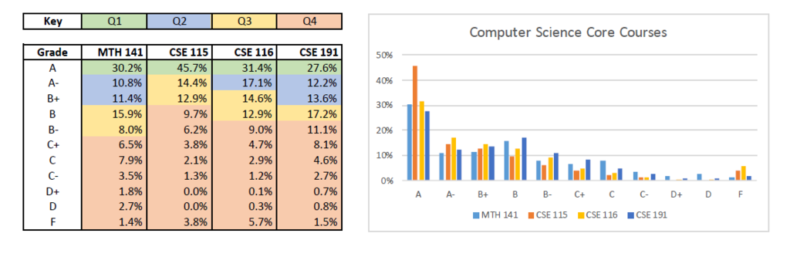

Academic Behaviors
Over the last academic year, what classes have you taken related to engineering or computer science? Be sure to consider all science and math related courses.
- Click or tap here to enter text.
Answer all of the following questions according to the classes you listed above and your core classes.

During classes
In the last academic year, have you attended all, most, some, or few of your core classes and the other classes you listed above?
- Click or tap here to enter text.
What was your note-taking method during your core classes and the other classes you listed above? (Be specific)
- Click or tap here to enter text.
What are three things that help you make the most of class time? (Be specific)
- Click or tap here to enter text.

Assessments
How did you prepare for your exams in this past academic year for your core classes and the other classes you listed above? (Be specific)
- Click or tap here to enter text.
When you received a homework assignment in a core classes and the other classes you listed above, what did you do to make sure it was done well and turned in on time? (Be specific)
- Click or tap here to enter text.

Working with others
When you did not understand class content or subject matter in a core classes and the other classes you listed above, who did you tend to reach out to for help? (E.g. TASS, TA, GA, study group, professor, etc.)
- Click or tap here to enter text.

Conclusion
What makes you confident that you will continue to be academically successful in the more rigorous engineering or computer science courses?
- Click or tap here to enter text.

Part 2: Focus2 Self-Assessment with Reflection
Being successful in a particular degree program and career requires more than cognitive ability. To help look at your interests, we are having you do Focus2.

Making an Account

Directions for Registering for Focus2
- Go to Focus2:
- “Register” an account if you have not already done so
  - Fill out all information. Your Access Code is ubbulls

Work Interest Assessment
- Scroll down to find the “Self Assessment “section
- Take the “Work Interest Assessment”
- On the results page, answer the following questions:
- What are your three areas from the “Results”? Put them in ranking order (e.g. 1, 2, 3)
  - Click or tap here to enter text.
  - Click or tap here to enter text.
  - Click or tap here to enter text.
- As you look at the bullet point descriptions of your top 3 interest areas, what do you agree with?
  - Click or tap here to enter text.
- As you look at the bullet point descriptions of your top 3 interest areas, what do you disagree with or question? (Be specific)
  - Click or tap here to enter text.
- How do your top two interest areas relate to what you have enjoyed in past (e.g. jobs, volunteering, internships, sports, clubs, and class projects or assignments)? (Be specific)
  - Click or tap here to enter text.
- How do your top two interest areas relate to UB’s engineering or computer science programs? (Be specific)
  - Click or tap here to enter text.
- Click ‘Continue’ at the bottom of the page
- Click “Sort By” and select “Job Family”
- Click “Update”
- What “Job Family’s” category do you see the most?
  - Click or tap here to enter text.
- What “Supporting Majors/Programs at University at Buffalo” do you see the most?
  - Click or tap here to enter text.
- Click on an Occupation that interests you.
- What about the “Job Tasks” interests you?
  - Click or tap here to enter text.
- What “Skills” match up with what you already have?
  - Click or tap here to enter text.
- What “Skills” would you need to develop?
  - Click or tap here to enter text.
- What do you think about the “Work Conditions”?
  - Click or tap here to enter text.
- Based on all of your responses, how well does engineering or computer science fit you as a major and field to pursue?
  - Click or tap here to enter text.
- Click the “Home” icon in the upper left-hand corner of Focus2

Personality Assessment
- Scroll down to find the “Self Assessment” section
- Take the “Personality Assessment”
- Click the “Home” icon in the upper left-hand corner of Focus2

Leisure Assessment
- Scroll down to find the “Self Assessment” section
- Take the “Leisure Assessment”
- On the results page, answer the following questions:
- What are your three areas from the “Results”? Put them in ranking order (e.g. 1, 2, 3)
  - Click or tap here to enter text.
  - Click or tap here to enter text.
  - Click or tap here to enter text.
- As you look at the bullet point descriptions of your top 3 interest areas, what do you agree with?
  - Click or tap here to enter text.
- As you look at the bullet point descriptions of your top 3 interest areas, what do you disagree with or question? (Be specific)
  - Click or tap here to enter text.
- How do your top two interest areas relate to what you have enjoyed in past (e.g. jobs, volunteering, internships, sports, clubs, and class projects or assignments)? (Be specific)
  - Click or tap here to enter text.
- How do your top two interest areas relate to UB’s engineering or computer science programs? (Be specific)
  - Click or tap here to enter text.
- Click ‘Continue’ at the bottom of the page
- Click “Sort By” and select “Job Family”
- Click “Update”
- What “Job Family’s” category do you see the most?
  - Click or tap here to enter text.
- What “Supporting Majors/Programs at University at Buffalo” do you see the most?
  - Click or tap here to enter text.
- Click on an Occupation that interests you.
- What about the “Job Tasks” interests you?
  - Click or tap here to enter text.
- What “Skills” match up with what you already have?
  - Click or tap here to enter text.
- What “Skills” would you need to develop?
  - Click or tap here to enter text.
- What do you think about the “Work Conditions”?
  - Click or tap here to enter text.
- Based on all of your responses, how well does engineering or computer science fit you as a major and field to pursue?
  - Click or tap here to enter text.
- Click the “Home” icon in the upper left-hand corner of Focus2

Combine Assessments
- Click “Combine Assessments”
- Select “Work Interest”, “Leisure Interests”, and “Personality”
- Click “Continue”
- Click “Sort By” and select “Job Family”
- Click “Update”
- If occupations appear in all three assessments, what “Job Family” do you see the most? If occupations do not appear in all three assessments, answer, “N/A”.
  - Click or tap here to enter text.
- If occupations appear in all three assessments, what “Supporting Majors/Programs at University at Buffalo” do you see the most? If occupations do not appear in all three assessments, answer, “N/A”.
  - Click or tap here to enter text.
- If occupations appear in all three assessments, what “Job Family” do you see the most? If occupations do not appear in all three assessments, answer, “N/A”.
  - Click or tap here to enter text.
- If occupations appear in all three assessments, what “Supporting Majors/Programs at University at Buffalo” do you see the most? If occupations do not appear in all three assessments, answer, “N/A”.
  - Click or tap here to enter text.
- Based on all of your responses, how well does engineering or computer science fit you as a major and field to pursue?
  - Click or tap here to enter text.
- Sign out of Focus2. You are done with this section!

Part 3: Informational Interviews
Before moving to the final reflection, it is helpful to seek feedback from a third party. We have provided the questions you need to ask. You are welcome to ask more questions, but are not required to do so.

Discussion #1: Someone You Admire
Name: Click or tap here to enter text.
Occupation: Click or tap here to enter text.

Questions for the Person You Admire
Share your information from Part 1 and 2. Ask, based on what I have shared, what do you think about me returning to the School of Engineering and Applied Sciences?
- Click or tap here to enter text.
When you have faced a crossroad (e.g. what to choose for a college major), how did you decide what direction to pursue? Please be as specific as possible.
- Click or tap here to enter text.
You may have told me before, but what do you think is important for me to remember as I continue in my academic and career journey?
- Click or tap here to enter text.

Conclusion for You
What about this person do you admire?
- Click or tap here to enter text.
How do their responses affect your decision to be a part of engineering or computer science?
- Click or tap here to enter text.

Discussion #2: A Junior or Senior in the Major
Name: Click or tap here to enter text.
If you need support in finding a junior or senior, please consider reaching out to Noelle Matthews, using UBLinked for student clubs, or asking any of your engineering friends who they may know.
Junior or Senior: Click or tap here to enter text.

Questions for a Junior or Senior in the Major
Share your information from Part 2 only. Ask, based on what I have shared, what do you think about me returning to the School of Engineering and Applied Sciences?
- Click or tap here to enter text.
How do you know that your major is the best one for you? Please be as specific as possible.
- Click or tap here to enter text.
What do you think I need to remember as I continue in my academic and career journey?
- Click or tap here to enter text.

Conclusion for You
How do you know this peer?
- Click or tap here to enter text.
How do their responses affect your decision to be a part of engineering or computer science?
- Click or tap here to enter text.

Discussion #3: Professional in the Field
Name: Click or tap here to enter text.
Occupation: Click or tap here to enter text.
If you need support, please consider setting up a 30-minute conversation with Career Services, going to a drop-in appointment at Career Services, or using the UB Career Connector Network.

Questions for a Professional in the Field
Be sure to share some details on why you are having this interview.
When you were in college, how did you know the major you chose was the right one for you? OR If you could go back, what would you have done differently about choosing your major?
- Click or tap here to enter text.
What do you wish you had known about this field when you were just starting out?
- Click or tap here to enter text.
What do you think I need to remember as I continue in my academic and career journey?
- Click or tap here to enter text.
Be sure to thank the person for their time and send a follow-up thank you note via email.

Conclusion for You
How could interviews like these with other professionals benefit you in the future?
- Click or tap here to enter text.
How do their responses affect your decision to be a part of engineering or computer science?
- Click or tap here to enter text.

Part 4 - Final Reflection
Congratulations, you have reached the final part of this career exploration assessment! While you have already reflected over your academics, Focus2, and informational interviews, this final reflection is meant to bring it all together.
What did you learn about yourself that you did not know before doing this mini-project?
- Click or tap here to enter text.
What common things do you see between your Focus2 results and you learned in your Informational Interviews?
- Click or tap here to enter text.
How do these common things influence your choice of major at UB?
- Click or tap here to enter text.
Moving forward, what are three things you want to remember to continue to be successful academically?
- Click or tap here to enter text.
- Click or tap here to enter text.
- Click or tap here to enter text.
Moving forward, what are three things you will do to accomplish any remaining core class grade requirements and the technical G.P.A. requirements?
- Click or tap here to enter text.
- Click or tap here to enter text.
- Click or tap here to enter text.
In the next 6 months, what do you plan on doing outside the classroom to be career-ready after college?
- Click or tap here to enter text.
What else do you want those who review this mini-project to know about you that the questions in this mini-project did not cover?
- Click or tap here to enter text.

